Sulakshana Mehta
CS 350: Emerging Systems Architectures and Technologies
Module Five Milestone Three: Input With Buttons
February 2, 2026
Step 1: Installing package
Installed Python package to develop an enhanced state machine.
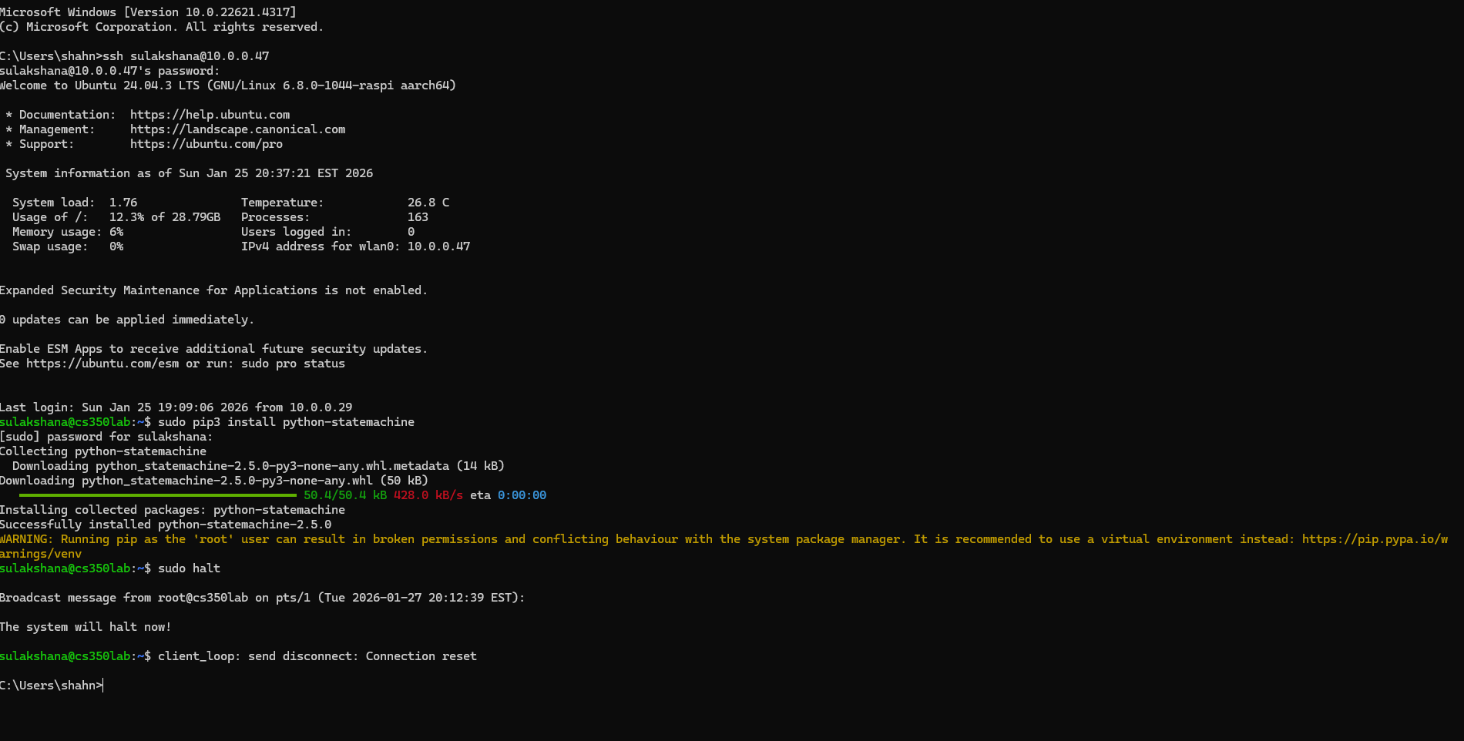
Step 2: Relocating red LED, jumper wires and resistors
After relocating the existing red LED ran the test.
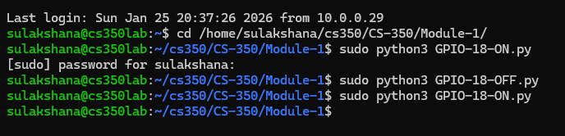
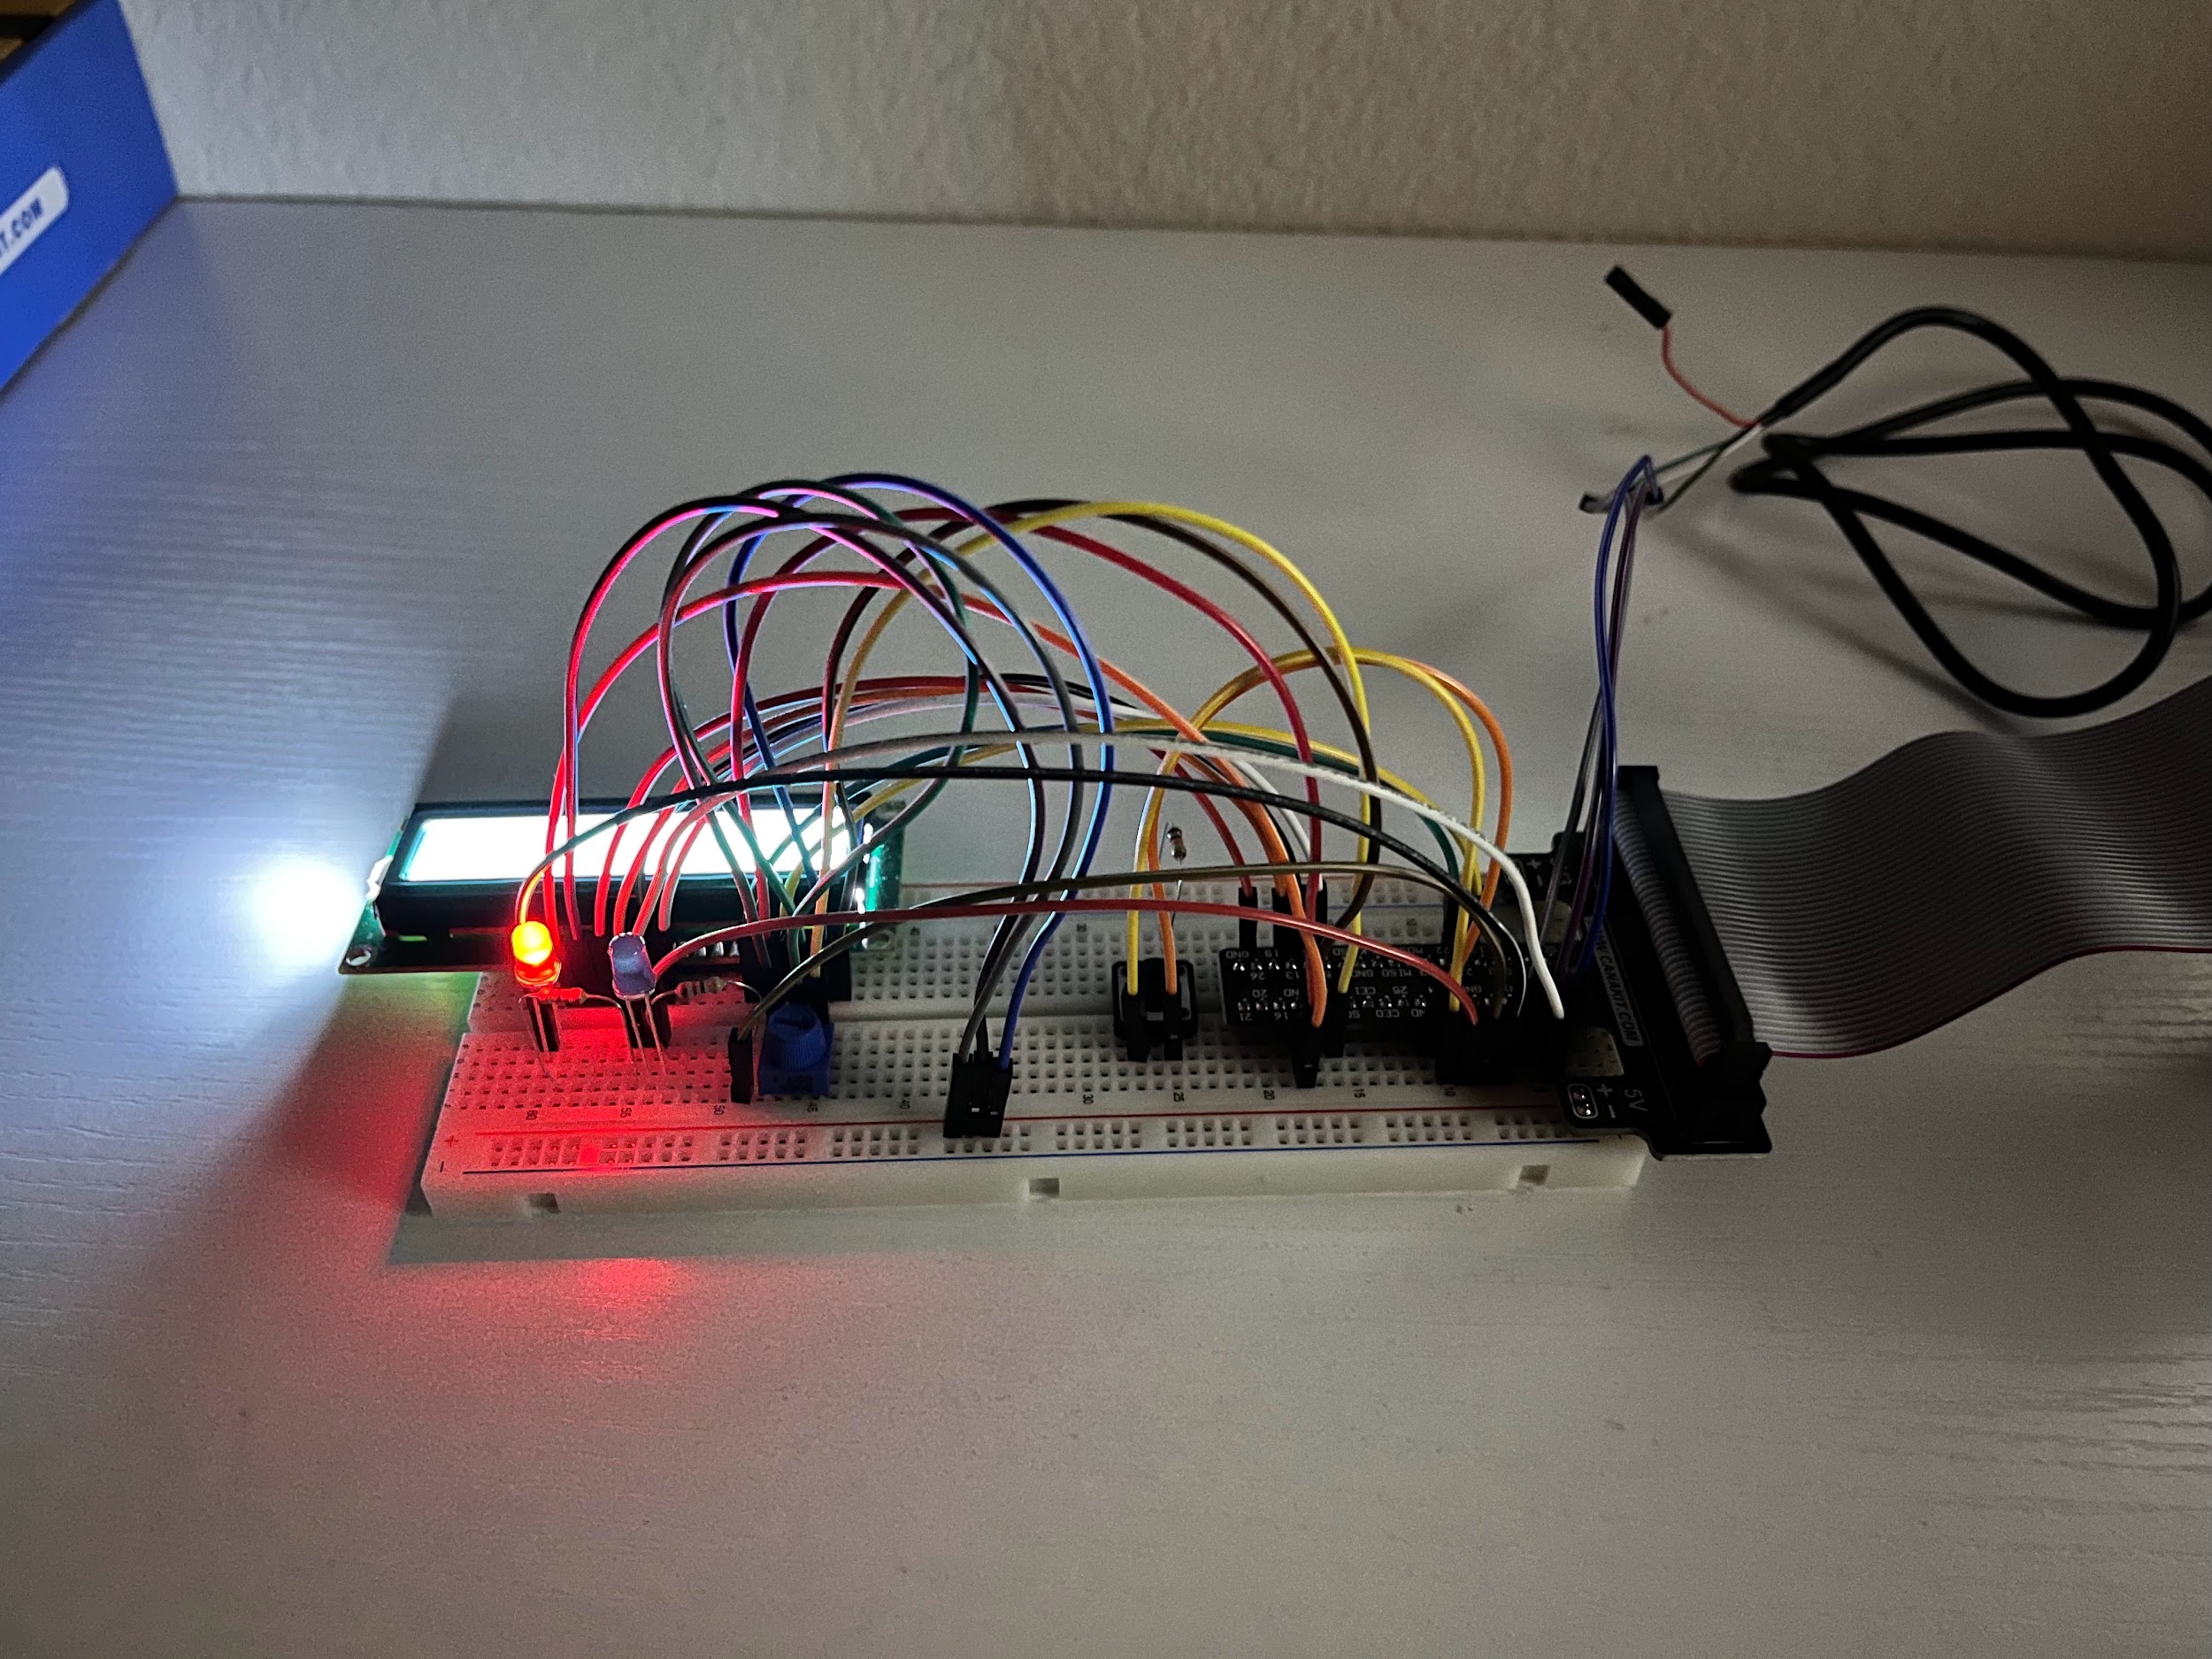
Step 3: Connecting Blue LED, jumper wires and 220 ohm resistor.
Connected Blue LED and ran the test for GPIO-23-ON.py and GPIO-23-OFF.py successfully.
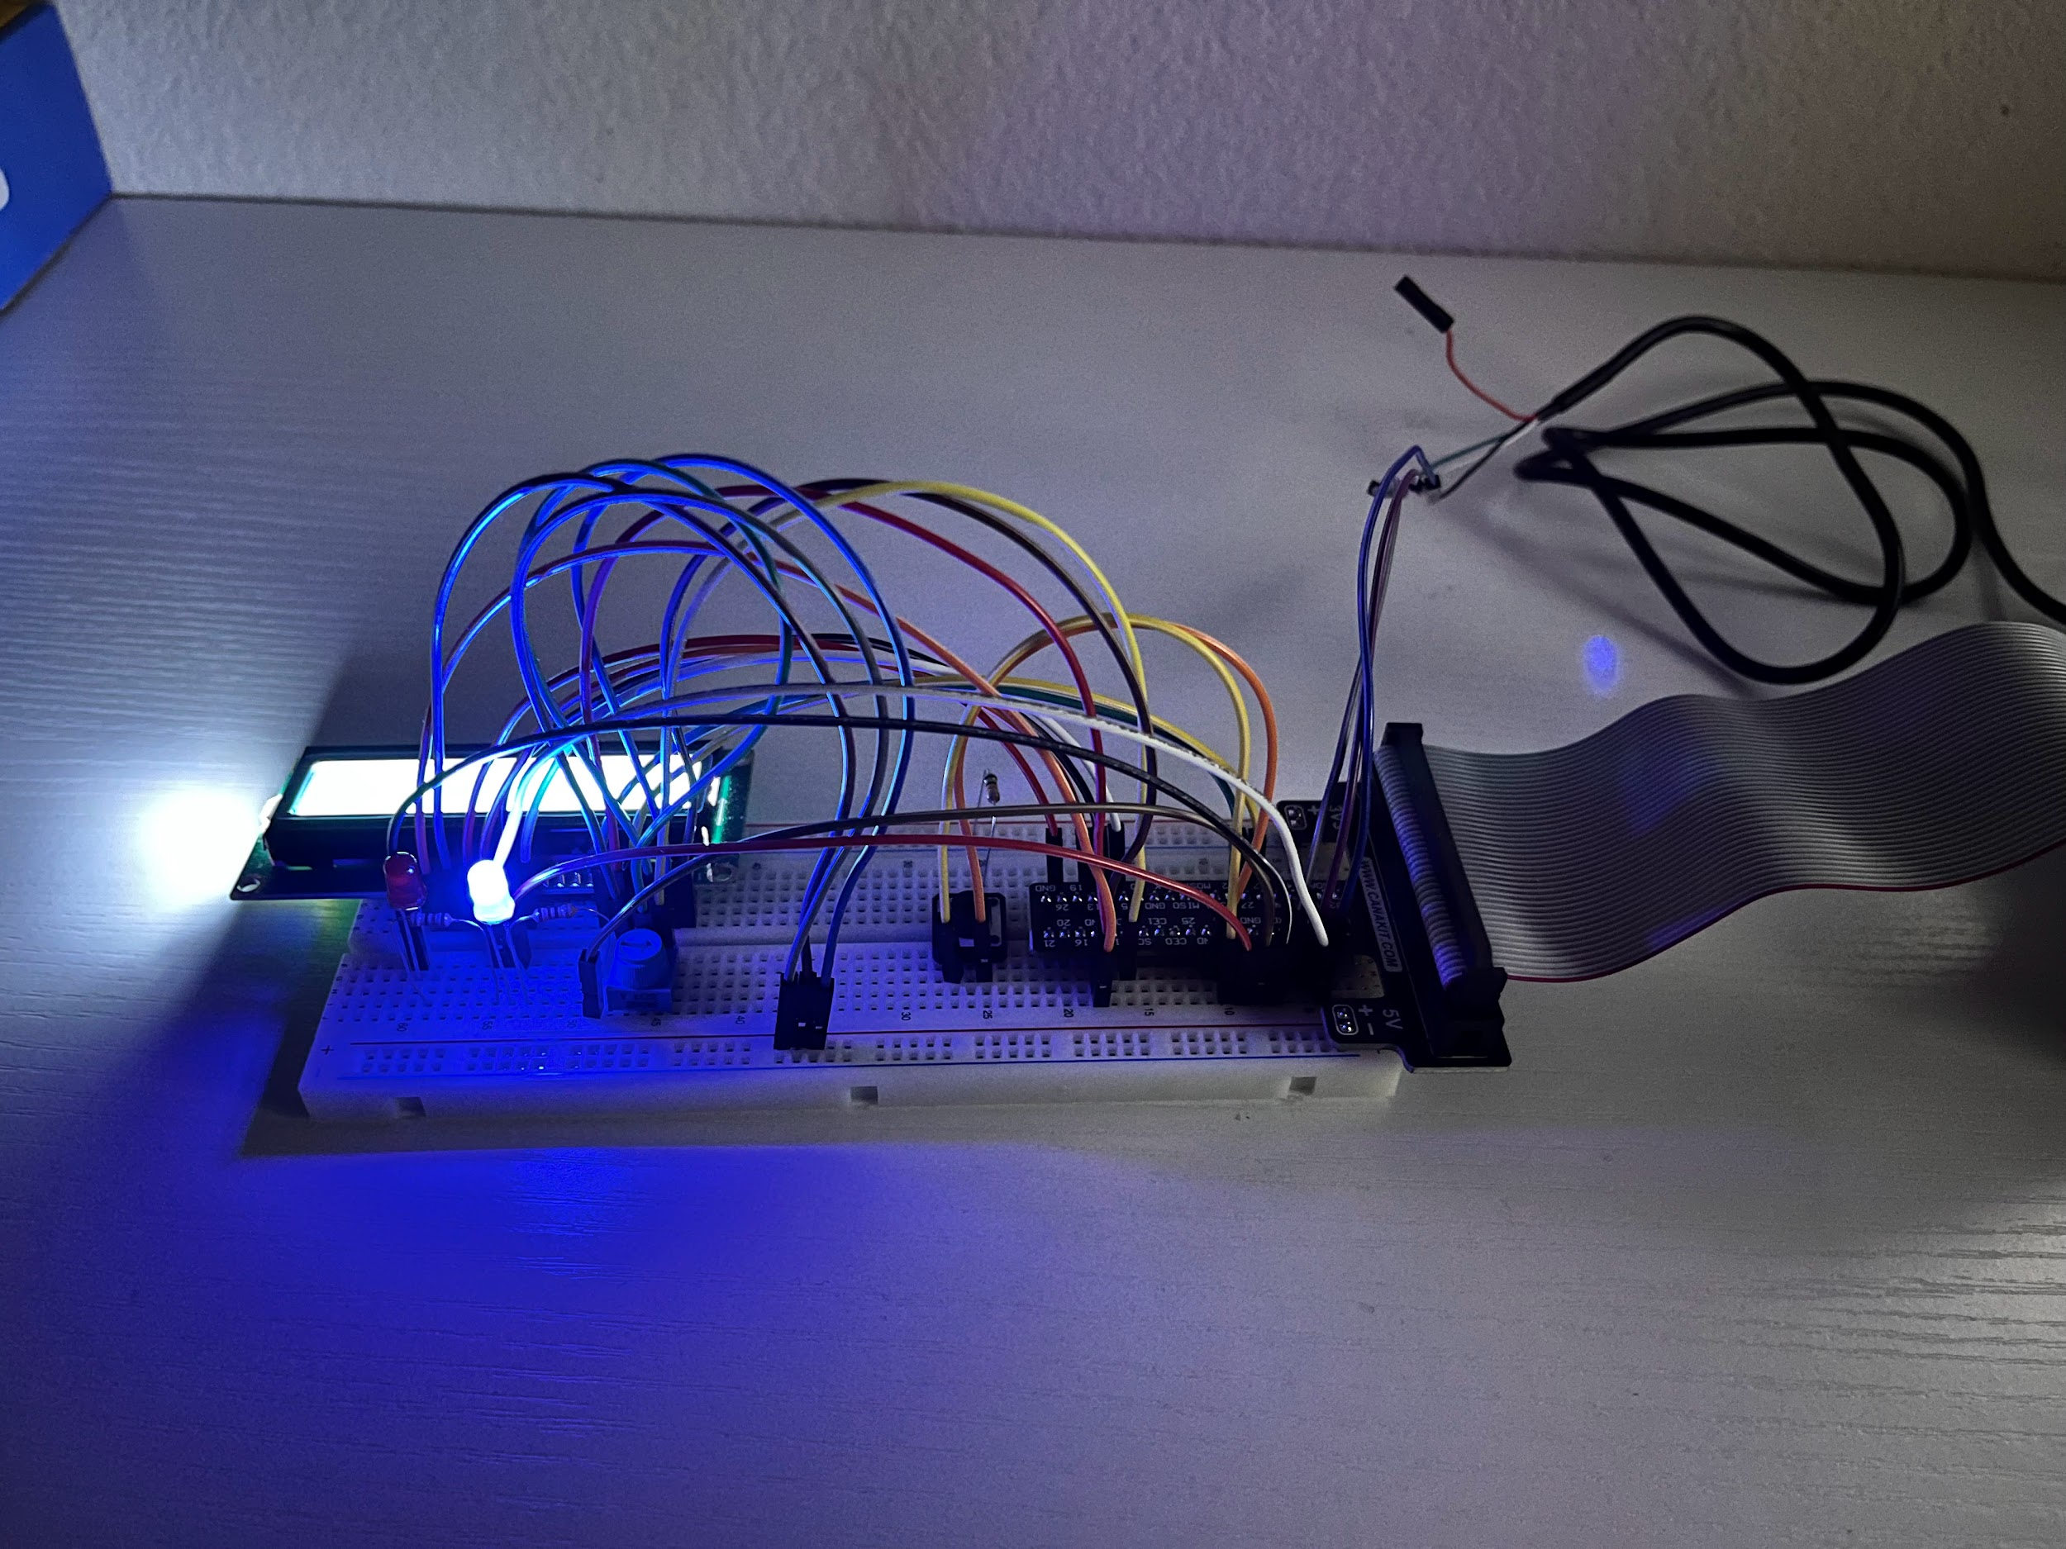
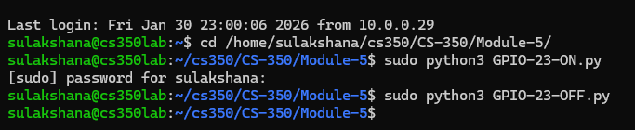
Step 4: Connecting button, 10K ohm resistor and two jumper wires:
As described in the lab guide all connections for press buttons are made on the breadboard.
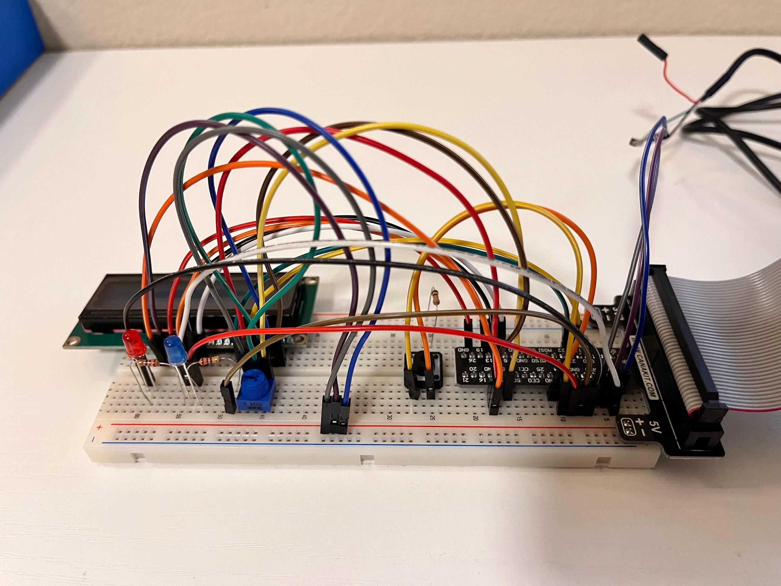
Ran the test file ButtonTest.py for button functionality. It worked as intended.
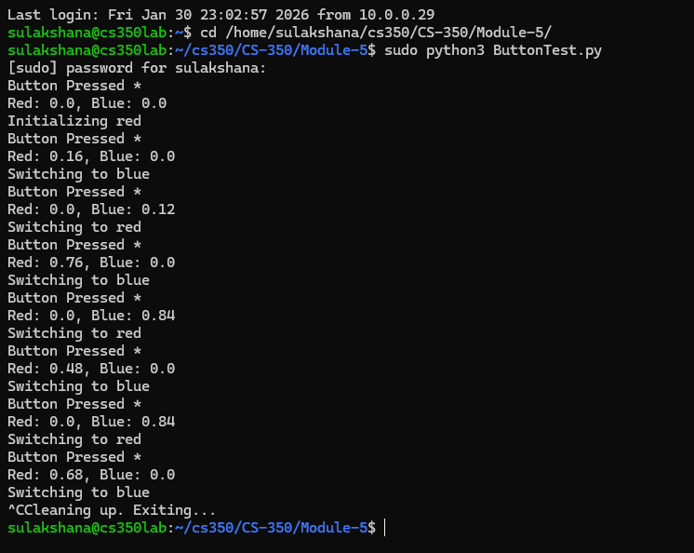
Step 5: Building a State Machine:
To verify the state machine functionality ran the file LightStateMachine.py and it gives following results:
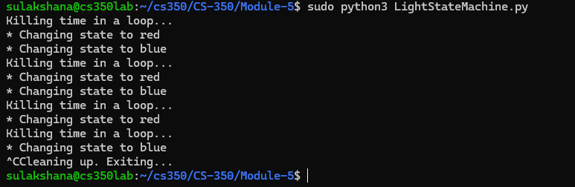
Step 6: Completing the Milestone Three:
- First step towards completing milestone three is to make the necessary changes to Milestone3.py software template and address each TODO section of the code.
- To begin with, in the on_enter_dot(self) method I added self.redLight.on() and sleep(0.5) to turn on the RED LED for 500ms one time. Next, on_enter_dash(self) method I added self.blueLight.on() and sleep(1.5) to turn on the BLUELED for 1500ms one time. Also on the exit method for both LEDs to turn them off I added self.redLight.off() and self.blueLight.off().
- After that, I applied necessary timing pauses for the Morse code using sleep() method into on_enter_dotDashPause(self), on_enter_letterPause(self) and on_enter_wordPause(self).
- The following code segment is added to the toggleMessage() method to switch between message 1 and message 2, which transitions between ‘SOS’ and ‘OK’ message.
if self.activeMessage == self.message1:
self.activeMessage = self.message2
else:
self.activeMessage = self.message1
- After that I added button configuration as following:
greenButton.when_pressed = cwMachine.processButton
- Finally, To make everything simple, I used a clean pattern: each Morse symbol would make a call to the relevant transition (doDot() or doDash()) and wait till the LED timing after which I call the transition again so that the state would be restored to the off state. This gives every operation a known state to begin and end with, and appropriate pauses should be placed between symbols, letters and words in the same pattern. This leads to accurate transmission of Morse code with precise timing which reacts to button presses without failure.
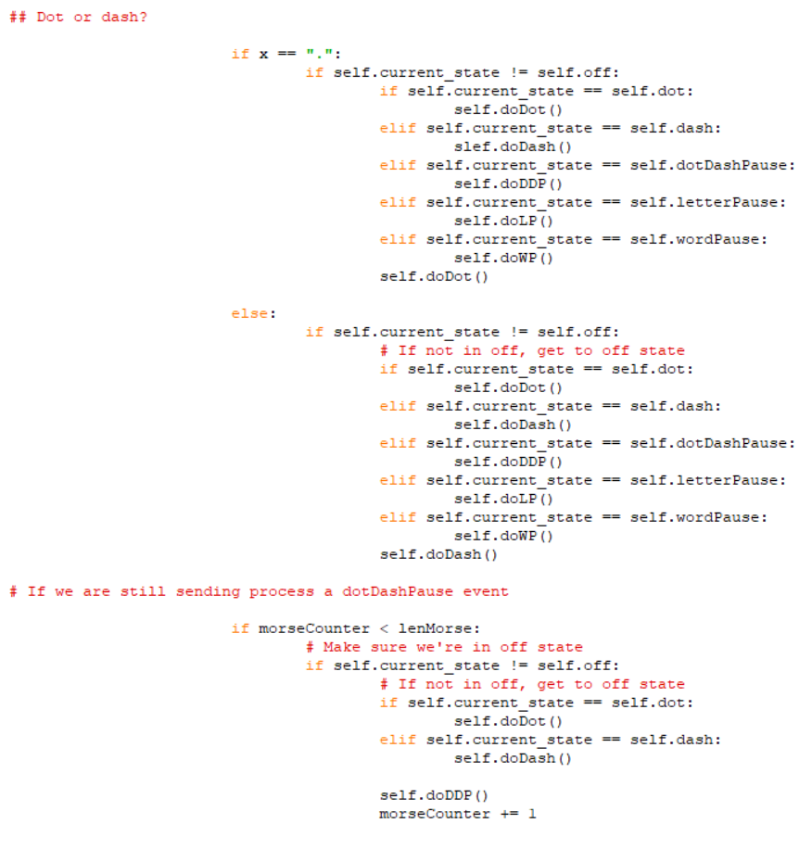
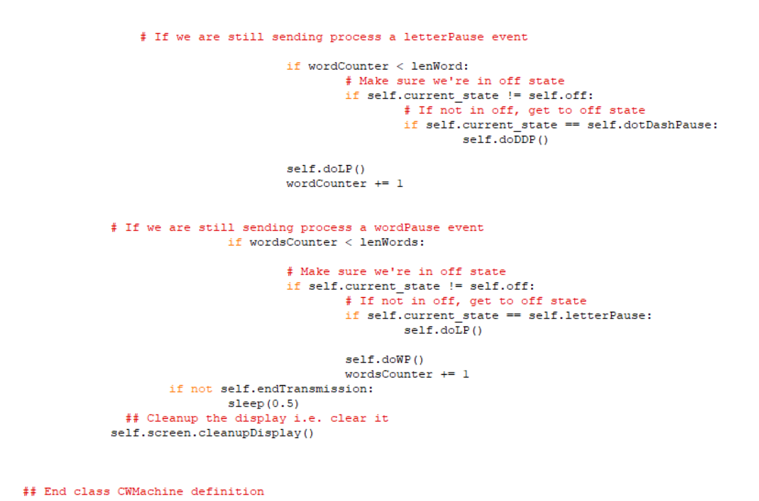
Following are previews of error messages I received while debugging the code.
- In the Milestone3. Py template originally it had bidirectional transitions like off.to(dot) | dot.to(off), but for proper flow I included transitions from pause states back to active states:
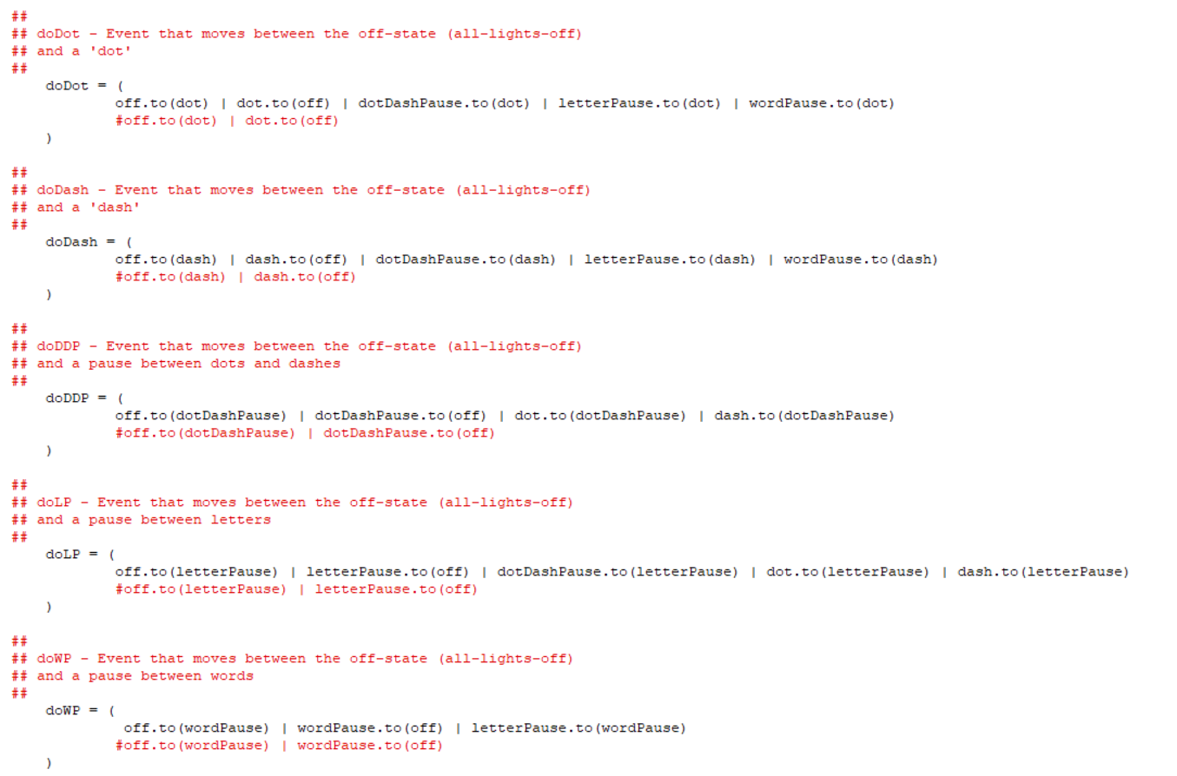

Error messages:
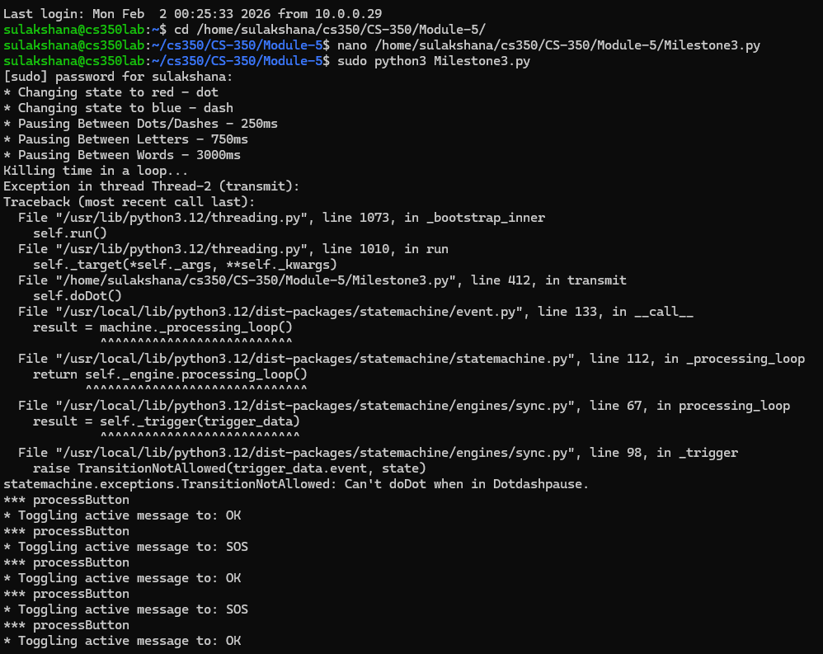
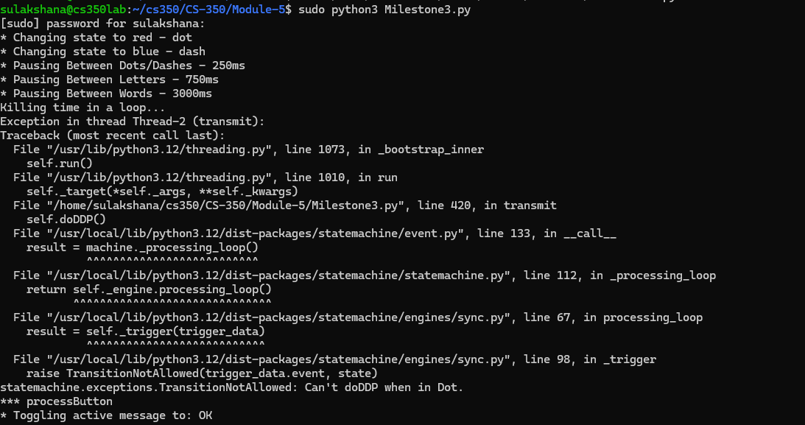
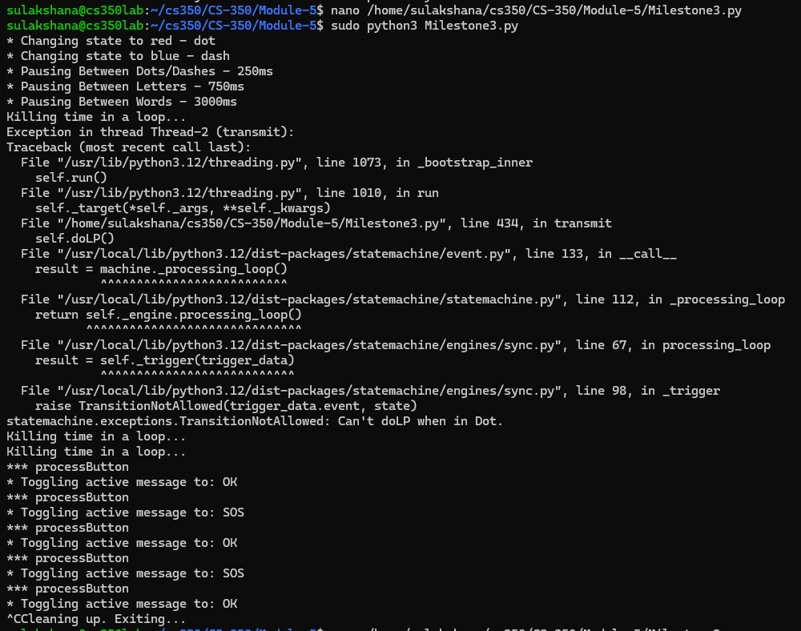
- After fixing the transition between states I had to fix some tabs and space indentations errors.
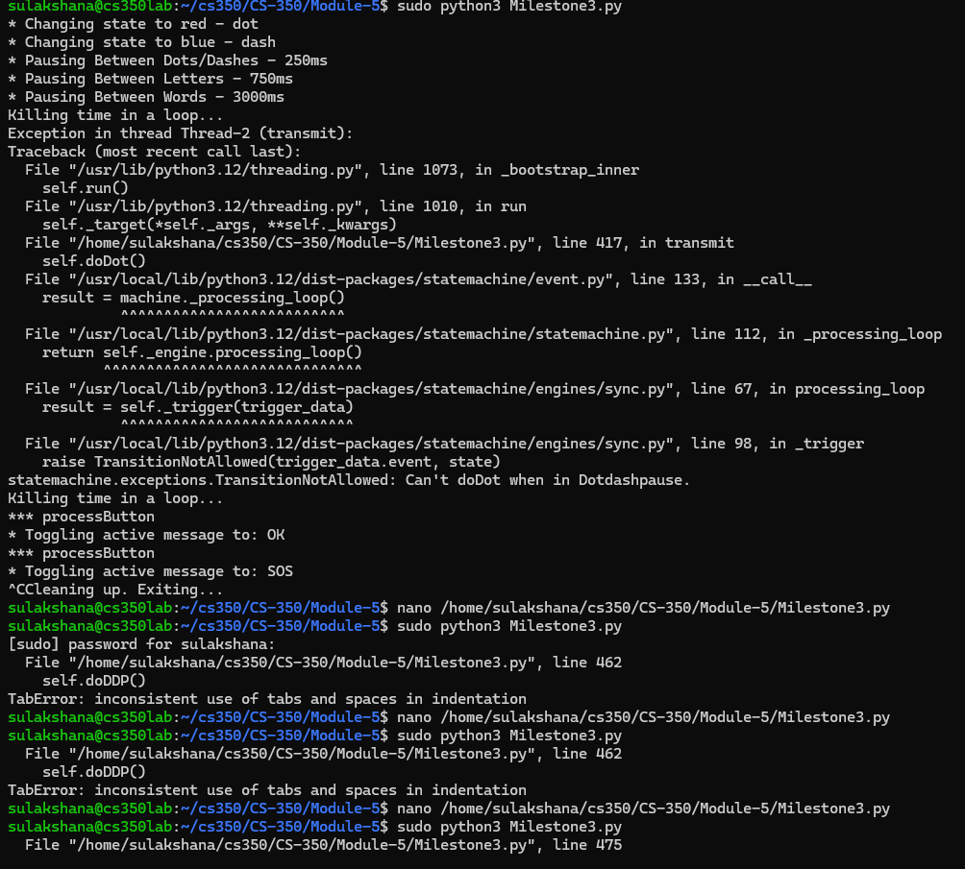
Finally after fixing all the errors I successful run the Milestone3.py test file:
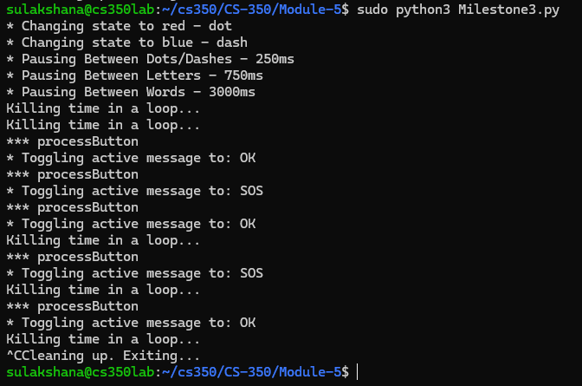
Video presentation of working code is attached with the final submission of lab 5.
Lab Questions:
1. Why does the loop that processes the LED blinking need to run in a separate thread?
Answer: The LED blinking loop functions in another thread in order to avoid stalling of the main program on timing delays. Morse code necessitates certain pauses between codes, 500ms represents dots whereas 1500ms represents dashes that would not allow the buttons to respond if they were registered in the primary thread. A worker thread is used to blink, and since the main thread is free, users can switch messages instantly without interrupting message transmission by responding to button presses.
2. What is the purpose of returning to the off state after each completed state action?
Answer: After returning to the off state the system is returned to a known idle state with both LEDs off. This provides clean transitions between the operations, avoids overlapping signals and the state machine design is simplified. Symbols in each of the Morse systems have the same baseline which ensures proper timing and makes the code easier to debug and maintain.
3. How could you integrate serial communications to facilitate changing the messages available to the program?
Answer: Serial communications could be incorporated by providing listener thread to access the command sent via a USB or UART connection. This would permit remote update without recoding, making the device a configurable Morse transmitter which can be controlled by another computer or microcontroller.
4. How could you use the 16x2 display to provide debugging information to the user when they don’t have access to the application console?
Answer: The debugging information can be displayed on the 16x2 display by simply using a debug mode toggle, activated by a button sequence, which cycles the diagnostic screens. The screens would show the current state, active message, error codes or system metrics and users would be able to troubleshoot directly on the machine without the use of external monitors or SSH.

